Grade : | 6 | Date: 4.02.2016
Theme : | I'll be a doctor
Aim of the lesson: | a)To develop pupils knowledge of the English in writing, reading, speaking  b) to introduce pupils with new material  c) to bring up pupils interests in different professions and to help them to love them, to enlarge pupils' vocabulary
Results of the study: | Жаңа тақырыппен танысады.  Келер шақтың жасалу жолдарымен танысады.  Алған білімдерін өмірде қолдана алады.  Өз пікірін ашық білдіруге үйренеді.
Visual aids: | Cards, computer, interactive board,
Модульдің кіріктірілуі: | Оқыту мен оқудағы жаңа тәсілдер, сыни тұрғыдан ойлауға үйрету. Оқыту үшін бағалау және оқу үшін бағалау. Ақпараттық-коммуникативтік технологияларды оқыту.
Бекітемін: Қ. Наубетов Мектеп директорының оқу-тәрбие ісі жөніндегі орынбасары

Parts of the lesson: | Time | Teacher's actions: | Pupils' actions: | Evaluating | Resources,  visual aids
I. Organization moment.  a) greeting with the pupils  b) Divide into groups  II. Checking up the homework.  III. Learning the new vocabulary.  IV. Explanation of the grammar structure Future Simple Tense  V. New lesson.  I'll be a doctor  VI. Phonetic drill  VII. Conclusion  VIII. Giving homework  IX. Reflection | 2 minutes  2 minutes  6 minutes  5 minutes  10minutes  5 minutes  3 minutes  5 minutes  2 minute | Good afternoon, pupils. I’m glad to see you. As you see, today we have got an unusual lesson. We have the guests. They are teachers. They came to our open lesson. We shall talk about the professions. There are a lot of professions all over the world, so we shall learn them during our lesson. Well, let’s check class atmosphere.  Divide into 4 groups    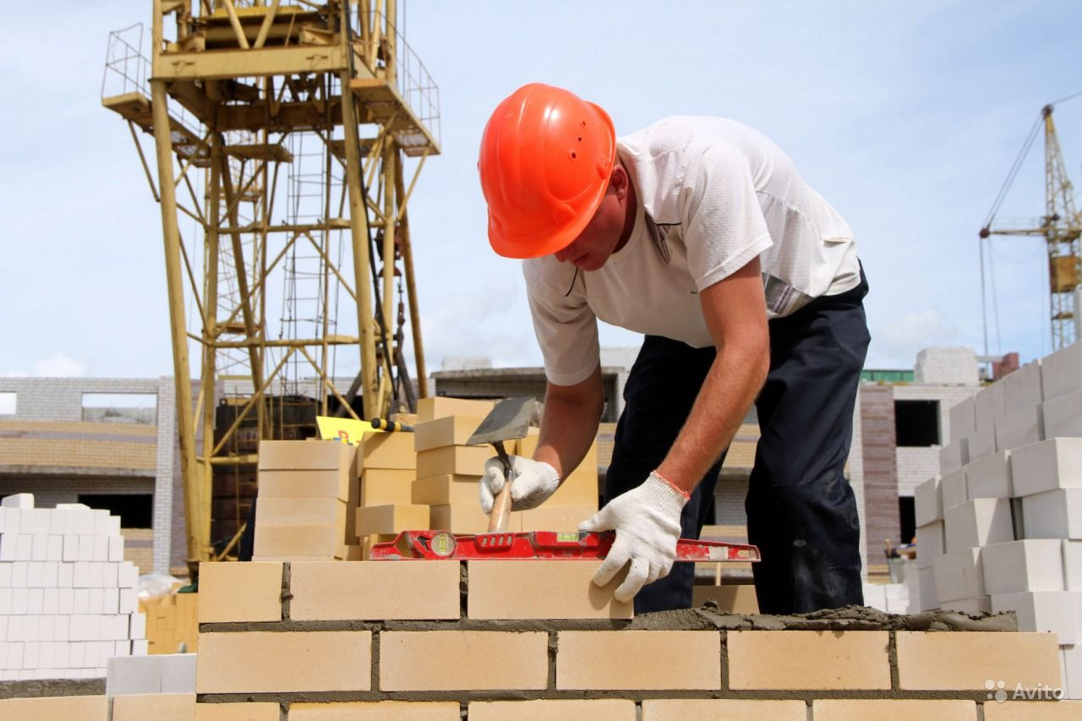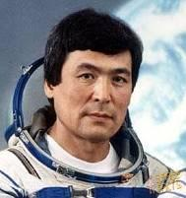  Ex 4 A P 133  Ex 10. P 138  Method “Identification”  Now, dear boys and girls we shall learn the new words. We’ll know how to pronounce the professions. At first, tell me what professions do you know? Very good. Well, look at the pictures and say the professions in Kazakh. Then listen to me very attentively.  You know that if we want to do something in the future we use the Future Tense in Russian and Kazakh, so I want to say that there is a Future Simple Tense in English too. Future Simple Tense you know it is Келер шақ. Now I want to explain the structure of the Future Simple Tense. The Future Simple Tense gives the meaning of the future actions planned before.  It is used for our plans and things we have decided to , If we want to speak about future. We use Future Simple. Future Simple is formed by the auxiliary verb.  Method “Sandwich of thinking”  1.I'll go to school by bus  2. She is....  Pupils I have a good news for you. I’ve taken the letter from London. The girl called Jane sent to you. Jane shares her opinion with you. By the way She is also in 6 form. Now Let’s listen and read it.  Ok, very nice. Pupils, Let’s play the game “Zoo”. I will give you the masks of different animals.  Method “Two truth, one lie”  1-group. Her name is Jane. Her dream is to become a doctor . Doctor is a bad profession.  2-group. She is 12 years old. She will treat patients and help people. She will be happy.  3-grup. Asel is from Atyrau. She is 13 years old. She is writing a letter to us  4-group. There are a lot of professions, but Asel's dream is to become a doctor. She won't be happy  I' be a ... | Pupils will divide according to the pictures into 4 groups:  “Doctor”,  “Teacher”,  “Builder”,  “Pilot  Pupils will identificate the sentences  Writing the new words  An artist [ a: tist ] Суретші  A programmer [ pr gramә ] Информатик  A doctor [ d ktә ] Дәрігер  A receptionist [ risep әnist ] Қабылдаушы  A lawyer [ l iә ] Заңгер  A pilot [ p ilәt ] Ұшқыш  A cosmonaut [ k zm n t ] Ғарышкер  A manager [ mәenәdzә ] Менеджер  A banker [ b nkә ] Банк қызметшісі  A designer [ dizainә ] Дизайнер  Noble [noubl]-құрметті,атақты  Recover [rik^vә]-жазылу,тәуір болу  Illness [ilnes]-ауру,сырқат  Wealth [welӨ]-байлық  I  You  He will +V  She  It won't + V  We  They  shall  Example: I will go to Astana next year. She will help her mother .  Letter.  Hello, my friends.  I am writing this letter from Astana. My name is Jane. I am 13 years old. I study at Grammar school. I want to share with you my ideas concerning profession.  Love, Asel  Everyone will speak about these animals.  Example: I’ll be a lion. I shall put on the mask of a lion. I’ll run fast like a lion. cow dog wolf cat  They will find 2 truth and 1 lie in the sentences    Write an essay | Formative assessment  “Clapping hands”    Formative assessment      “Praising” “Thumb”  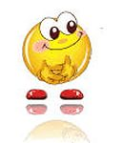 | Profession's pictures  Interactive board  Vocabulary, new words  Slaid  Distribution papers  AКТ
  Тапсырма | Бұл туралы не білесің? | Тағы қалай өзгертуге болады? | Ерекшелігі неде?
  I'll go to school by bus
  Бағалау
  + - !

Method “Moon”
- full moon  I understand |  -half moon  I understood half | - new moon  I don't understand many tasks

